POLITICAL SCIENCE FORUM
REPORTS OF ACTIVITIES
SESSION: 2023-2024

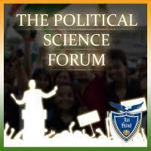

PG DEPARTMENT OF POLITICAL SCIENCE
HANS RAJ MAHILA MAHA VIDYALAYA
JALANDHAR

POLITICAL SCIENCE FORUM
SOCIETY OF POLITICAL SCIENCE DEPARTMENT

The Political Science Forum mainly aims to encourage understanding of political ideas, norms, behaviors, and institutions, and to inform public choices about State, government, governance, political system and public policy.

VISION
- To provide the Constitutional Knowledge
- Motivation of students towards value of vote in a Political System
- To create awareness among the Students
MISSION
- To create a free, just and humane society.
- To value of vote for all
- To Communicate the knowledge of Political Science
- To inculcate political values to boost democratic practice
STRUCTURE OF POLITICAL SCIENCE FORUM
In-charge: Dr. Jiwan Devi, Assistant Professor in Political Science
Secretary- Ms. Saloni Metlaw (Roll No-10509 B.A Sem-V Hons Political Science)7087333120
Joint Secretary- Arpandeep Kaur ( Roll No-11206 B.A Sem-III Political Science) 9313937541
Assistant Secretary- Bhumika Pandey (Roll No -11534 B.A Sem-I Political Science) 9041549277

PG Department of political science (ACTICITIES in
SESSION: 2023-2024)

Celebrate Independence Day with a Patriotic Rally (15 August 2023)
The PG Department of Political Science and Political Science Forum conducted in a spirited display of patriotism and reverence for the nation's freedom struggle, the students of Hans Raj Mahila Maha Vidyalaya came together to commemorate India's Independence Day with a vibrant rally. The event organized by PG Department of Political Science and Student Council under the motivation of Principal Prof.Dr. (Mrs.) Ajay Sareen, was a powerful testament to the enduring spirit of freedom and unity that continues to define the nation. Marking the solemn occasion, the students raised fervent slogans that echoed the sacrifices of the countless freedom fighters that valiantly battled for India's independence. With voices raised in unison, the participants paid a heartfelt tribute to the brave men and women who selflessly dedicated their lives to securing the nation's liberty. The event saw an outpouring of patriotic fervor, as faculty and students proudly donned handmade badges emblazoned with the tricolour and wore the tricolour attire, symbolizing the unity of the nation and the collective aspirations of its people. A student under the banner of Student Council brought a cake which marked her maiden product initiating her start up. Mrs. Navroop, Head of Punjabi Department and Dr. Seema Marwaha Dean Academics cut the cake and wished their best for her success. Speaking about the event, Dr. Ajay Sareen said, "The Independence Day rally at HMV is not just a celebration, but a heartfelt homage to the sacrifices of our forefathers who bestowed upon us the gift of freedom.
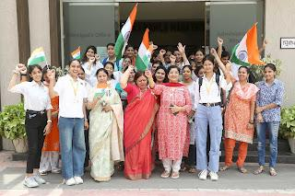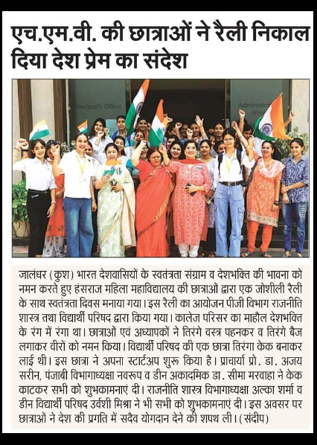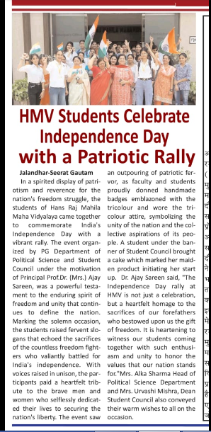
It is heartening to witness our students coming together with such enthusiasm and unity to honor the values that our nation stands for."Mrs. Alka Sharma Head of Political Science Department and Mrs. Urvashi Mishra, Dean Student Council also conveyed their warm wishes to all on the occasion. The event concluded with a renewed sense of commitment to the nation's progress, as the students departed with a shared resolve to contribute positively to the growth and development of India.HMV remains dedicated to nurturing not only academic excellence but also a sense of national pride among its students. The Independence Day rally served as a reminder that the youth of today are the torchbearers of tomorrow's India, and their unity and dedication will shape the destiny of the nation.
SVEEP Activities (7 November 2023)
The PG Department of Political Science and Political Science Forum conducted SVEEP Activities under the able guidance of Principal Prof. Dr. (Mrs.) Ajay Sareen. The PG Department of Political Science has conducted an Interclass Essay Writing Competition on the Topic, “MY Vote, My Responsibility” . 30 students of HMV Collegiate Sr. Sec. School, College and Resident Scholars participated in this competition.
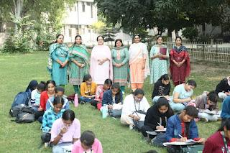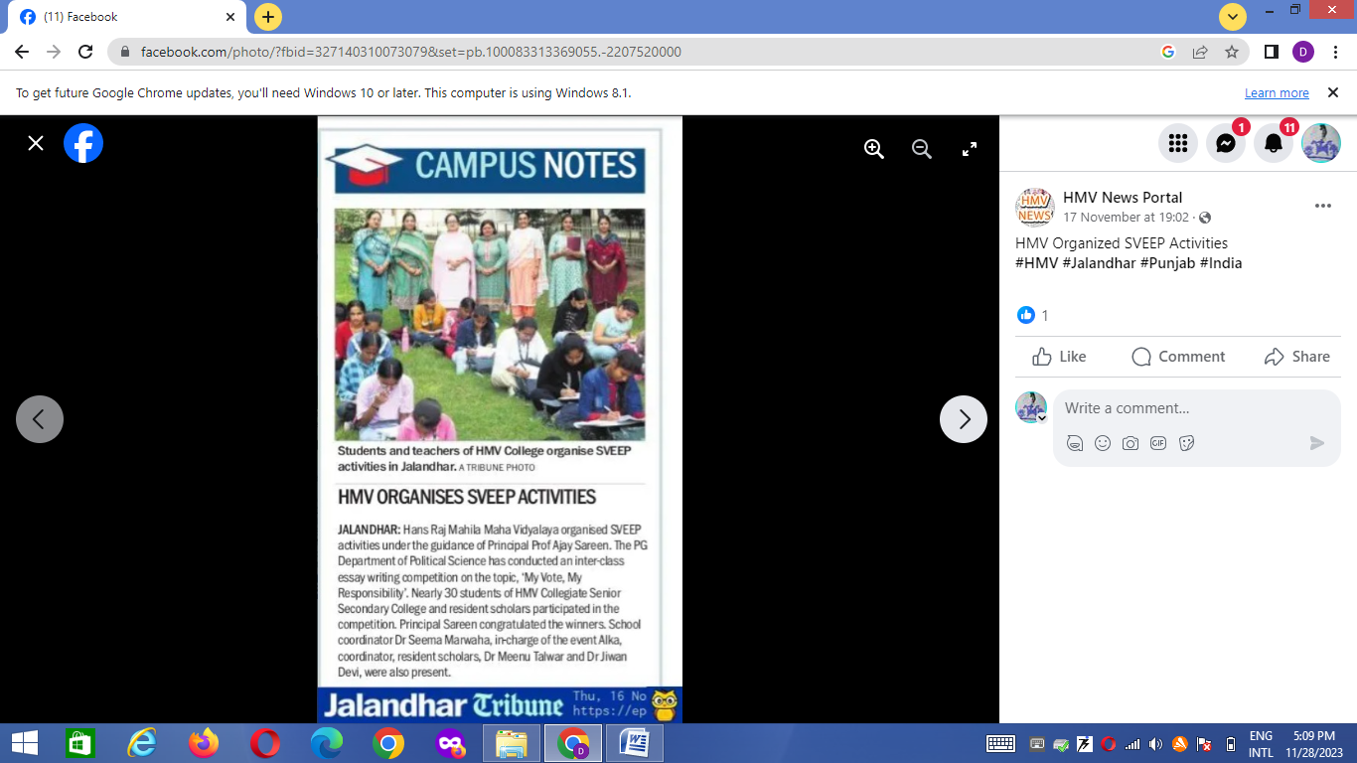
The judges of the event were Mrs. Lovleen Kaur, Mrs. Pawan Kumari and Dr. Sandeep. Principal Prof. Dr. (Mrs.) Ajay Sareen congratulated the winners. On this occasion School Coordinator Dr. Seema Marwaha, Incharge of the event Mrs. Alka, Coordinator Resident Scholars Dr. Meenu Talwar and Dr. Jiwan Devi were also present.
Inter Zonal Quiz and Zonal Quiz
The one student of Saloni in Political Science Forum participated in Quiz Team and won Inter Zonal and Zonal Quiz Competition held at GNDU Amritsar with a huge difference of more than 550 marks. Team members were Shivani Bhadula, Saloni Metlaw and Alisha Bamrah. Principal Prof. Dr. (Mrs.) Ajay Sareen congratulated the team members and teachers associated with the team. She told that HMV won first position in Quiz by defeating the teams of GNDU Campus, BBKDAV College Amritsar and APJ College of Fine Arts, Jalandhar, on the main stage. Principal Prof. Dr. (Mrs.) Ajay Sareen said that Quizzing showcases intellectual talent and skill, hard work and perseverance. She congratulated the team for their record breaking historic win. Principal Dr. Sareen said that it is the hard work of the teachers and students because of which HMV won first position in Inter Zonal.
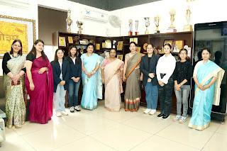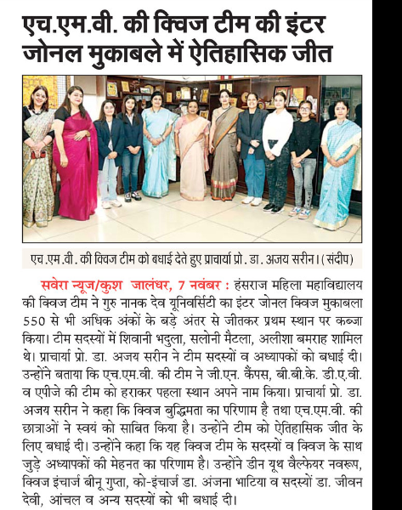
She also congratulated Dean Youth Welfare Mrs. Navroop, Quiz Incharge Mrs. Binoo Gupta, Co-Incharge Dr. Anjana Bhatia members Dr. Jiwan Devi, Mrs. Anchal and others.

Political Science Forum Secretary- Ms. Saloni Metlaw (Roll No-10509 B.A Sem-V Hons Political Science)7087333120 (Quiz Team Member)
BA Political Science Hons. Serm V
PG DEPARTMENT OF POLITICAL SCIENCE

Students Achievements 2023-2024

S.No. | Name of Activity | Organized by | Name of Student Participated | Roll No. & Class | Position | E-mail Id & Contact No | Certificate
1. | Zonal Level Youth Festival - Quiz | GNDU Amritsar | SaloniMetlaw | B.A. HonsSem V | Second | Email- salonimetlaw@gmail.com  Contact no. - 7087333120
2. | Inter-Zonal Youth Festival -Quiz | GNDU  Amritsar | SaloniMetlaw | B.A. HonsSem V | First | Email- salonimetlaw@gmail.com  Contact no. - 7087333120
3. | Northzone Youth Festival - Quiz | Punjabi University, Patiala | SaloniMetlaw | B.A. HonsSem VI | Third | Email- salonimetlaw@gmail.com  Contact no. - 7087333120
4. | National Youth Festival | Punjab Agricultural University, Ludhiana | SaloniMetlaw | B.A. HonsSem VI | Participated | Email- salonimetlaw@gmail.com  Contact no. - 7087333120
5. | Viksit Bharat@2047 Declamation contest | At Khalsa College for Women. Organaised by Nehru Yuva Kendra | SaloniMetlaw | B.A. HonsSem VI | Participated | Email- salonimetlaw@gmail.com  Contact no. - 7087333120
6. | District Level Speech Competition on Voters day | Organaised by KMV | SaloniMetlaw | B.A. HonsSem VI  10509 | Participated | Email- salonimetlaw@gmail.com  Contact no. - 7087333120
7. | District Level YuvaUtsav India@2047 | HMV Organised by Nehru Yuva Kendra | SaloniMetlaw | B.A. HonsSem V | First | Email- salonimetlaw@gmail.com  Contact no. - 7087333120 | 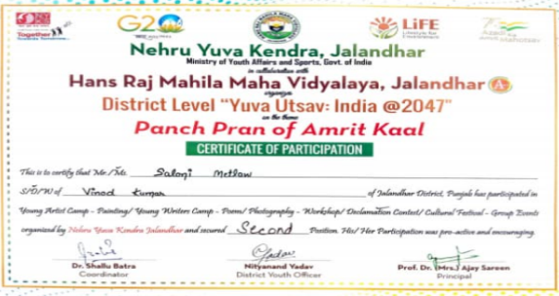
8. | Swachhata League 2.0 Declamation Competition | Organised by Municipal corporation and NSS dept. (HMV) MOHUA | SaloniMetlaw | B.A. HonsSem V | First | Email- salonimetlaw@gmail.com  Contact no. - 7087333120
9. | Poetry Recitation Competition | Organised by Budding Brontes Society | SaloniMetlaw | B.A. HonsSem V | Third | Email- salonimetlaw@gmail.com  Contact no. - 7087333120 | 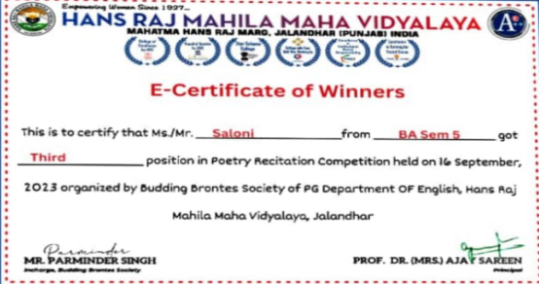
10. | Hindi Poetry Recitation Competition | PG Department of Hindi | SaloniMetlaw | B.A. HonsSem V | Third | Email- salonimetlaw@gmail.com  Contact no. - 7087333120

Constitution Day celebration 25th November 2023
The PG Department of Political Science and Political Science Forum celebrated Samvidhan Divas - Constitution Day to commemorate the adoption of the Constitution of India and to honour the values and principles of the Founding Fathers of the Constitution of India. As per the directives of University Grant Commission, Ministry of Education, Govt. of India, to celebrate Samvidhan Diwas (Constitution Day) Principal Prof. Dr. Mrs. Ajay Sareen, Mrs. Alka, Head of Department, Dr. Jiwan Devi faculty member and the students of PG and UG classes of PG Department of Political Science became the part of an online Activity to 'Read the Preamble ' of the constitution of India in 22 Official languages and English on My Gov.Portal.
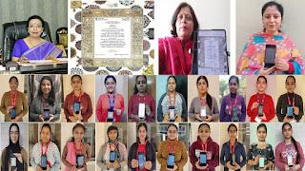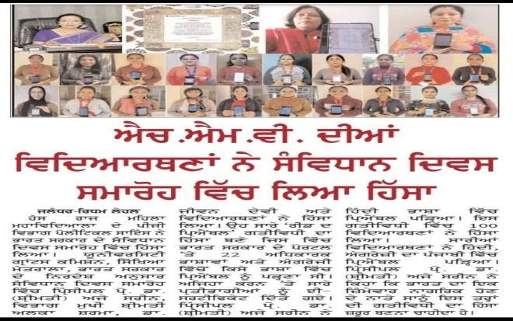
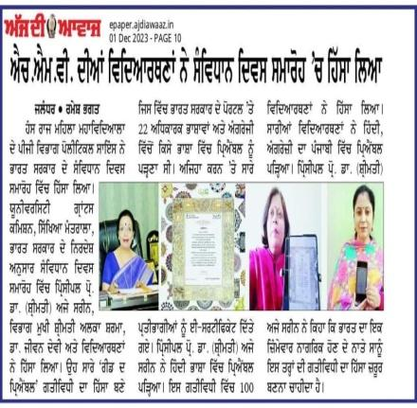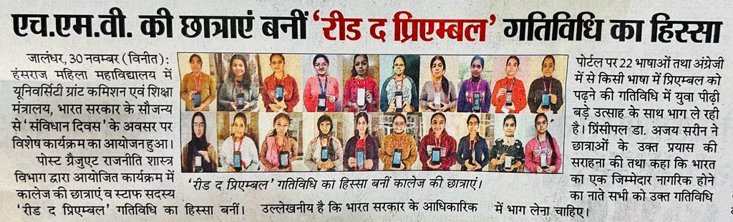

All the participants got an online Certificate of Participation from the Ministry of Parliamentary Affairs. Principal Prof Dr. (Mrs.) Ajay Sareen read the Preamble in Hindi language. 100 students participated in this activity. All students got online certificates in the respective language in which they read the Preamble as in English, Hindi and Punjabi. Principal Prof. Dr. Mrs. Ajay Sareen said that being a responsible citizen of the country, we all should participate in such activities.

75th Anniversary International Human Rights Day celebrated at HMV Collegiate School ( 9th December 2024)

The PG Department of Political Science and Political Science Forum conducted 75th International Human Rights Day was celebrated at HMV Collegiate Sr. Sec. School by the Department of Political Science and Political Science Forum and the able guidance of Principal Prof. Dr. (Mrs.) Ajay Sareen. The programme started with DAV Gaan. On this day, various competitive events such as Poster Making, Slogan Writing, Declamation and Quiz Competition were organized on the theme ‘Importance of Human Rights and Fundamental Rights: Freedom, Equality and Justice for All’. Students enthusiastically participated in different events and provided knowledge and awareness of Human Rights. A video clip was also shown to the students regarding Why we Celebrates Human Rights day and brief history of Human Rights. The chief guest of the day was Principal Prof. Dr. (Mrs.) Ajay Sareen. While addressing the students, Dr. Sareen said that Human Rights are based on the Principles of Human Solidarity, Cooperation and Development. She said that universal declaration of human rights is a milestone document that proclaimed the inalienable rights which everyone is inherently entitled to as human being, regardless of race, colour, religion, birth, etc. Dr. Seema Marwaha, Dean Academics and School Coordinator, While addressing the students, the NHRC is responsible for the protection and promotion of human rights, defined by the act as Rights Relating To Life, liberty, equality and dignity of the individual guaranteed by the constitution or embodied in the international covenants and enforceable by courts in India. Mrs. Arvinder said that we should not only enjoy all our rights but also perform our duties. Dr. Jiwan Devi said that International Human Rights Day is turning 75. It is the day, i.e. 10th December, 1948, when United Nations General Assembly adopted the Universal Declaration of Human Rights.

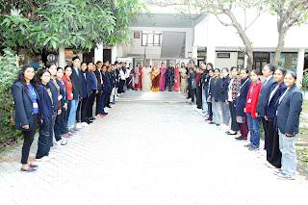

The event ended with the Judgment done by Mrs. Ritu Bajaj, Dept. of English, Dr Jyoti Gogia Head of Hindi Dept. and Dean Innovation Dr. Anjana Bhatia (Poster Making/Slogan writing and Declamation Competition). Quiz conduct two rounds Preliminary and Stage round conduct by Dr. Jiwan Devi. In poster making/ slogan writing competition, the first position was won by Anushka Gosain, second position was bagged by Himanshi, third position was bagged by Hezal Kapoor and consolation was won by Harpreet Kaur and Mandeep Kaur. In declamation competition, the first was won by Angel, second position was won by Simranjit Kaur Dhaliwal, and third position was bagged by Divyanshi. In Quiz competition, the first was won by Shagun and Riya, second position was won by Sakshi and Puneet Kaur, third position was bagged by Simranjit Kaur Dhaliwal and Ridhi. On this occasion of 75th International Human Rights Day “A Human Chain” is made by the students. Stage was conducted by Dr. Jiwan Devi and student Ritika Sharma. Mrs. Roma gave vote of thanks.
Various Competitions for celebrating National Voters’ Day (22 January 2024)
The PG Department of Political Science and Political Science Forum conducted various competitions for celebrating National Voters' Day in collaboration with Deputy Commissioner-cum-District Election Officer under the able guidance of Principal Prof. Dr. (Mrs.) Ajay Sareen. Students from different colleges of District Jalandhar participated in these competitions. The topic for the competitions of Painting/Drawing/Poster Making is “Voters Awareness and Participation in Election in India”. Principal Dr. Ajay Sareen gave best wishes to Coordinators Dr. Anjana Bhatia Dean Innovation and Mrs. Alka Sharma Head of Political Science Department and Co-Coordinator Dr Jiwan Devi for conducting these competitions and motivated the students to take part in the events for the boosting their confidence and to become more self reliant.
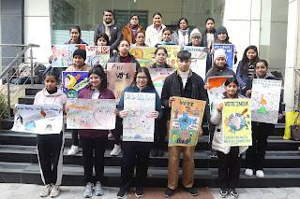
The students participated in the event with full enthusiasm. In Poster competition Reeva Sharma, BFA Sem- VI, HMV got first position, Gursharandeep Singh, B.Sc FD, CT group of Institution got second position ,Diya Sharma, BALLB, GNDU, Regional Campus got third position. In Painting competition Simranjeet Kaur BCA Sem- II, CT group of Institution got first position Namandeep Kaur, B.Tech Sem- III, GNDU, Regional Campus got second position and Isha, BFA Sem- II, HMV got Third Position. The judges of the event were Dr Rakhi Mehta, Dr Neeru Bharti Sharma and Dr Shailender Kumar.
14th National Voters’ Day (25th January 2024)
The PG Department of Political Science and Political Science Forum organized 14th Voters Day in collaboration with District Election Office, Jalandhar under the able guidance of Principal Prof. Dr. (Mrs.) Ajay Sareen. The chief guest of the event was Deputy Commissioner Jalandhar Sh. Vishesh Sarangal, IAS. The event started with the lighting of lamp. The other guests of the event were ADC (Rd) Sh. Jasveer Singh, JDA Sh. Darbar Singh, SDM-I Sh. Balbir Raj, Sh. Sukhdev Singh Election Tehsildar. All the guests were welcomed and felicitated with planters. Principal Prof. Dr. (Mrs.) Ajay Sareen congratulated all on the National Voters Day. She also urged all the citizens of India to be aware of our National duties. Principal Dr. Ajay Sareen expressed her gratitude towards Election Commission for assigning this event to HMV for consecutively 10th time. On this occasion, the folk song ‘Voter Jugni’ was presented. Then the CEC of India Sh. Rajeev Kumar addressed the audience in a video message. It was followed by a speech on the importance of casting a vote by Astt. SVEEP Nodal Officer Dr. Ashok Sahota. A Nukkad Naatak ‘Vote Pao, Desh Bachao’ was presented by the students of HMV.
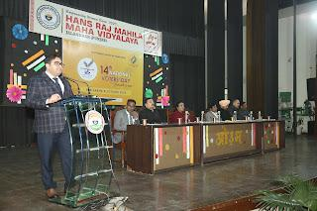 | 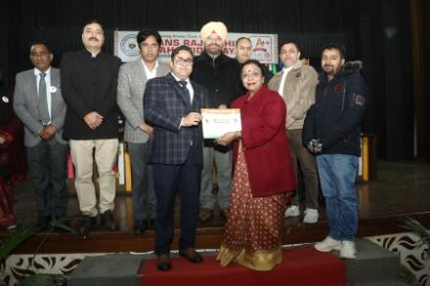 | 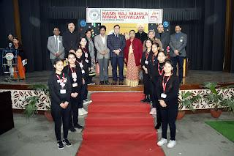
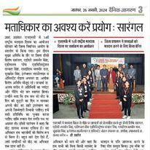 | 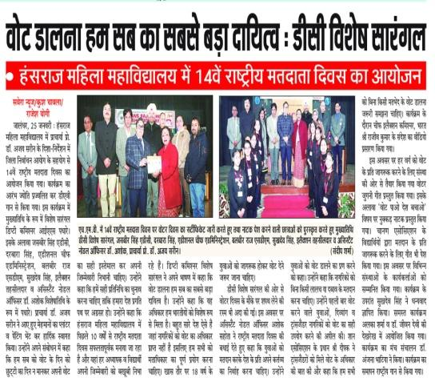
This Nukkad Naatak was prepared under the guidance of Dr. Veena Arora and Dr. Kajal Puri. After this Tushar the winner of speech competition and Ms. Saloni delivered their speeches on democracy and the importance of voting. It was followed by a group song ‘Hum Vote Dene Jayenge Is Desh Ke Liye’ sung by the members of Chaanan Vocational & Skill Training Centre. The chief guest of the occasion Sh. Vishesh Sarangal addressed the audience and said there is an urban apathy not the caste vote. He encouraged the voters to cast their vote for the bright future of their country. It was followed by voter’s pledge. It was followed by the honouring ceremony of the members who contributed in the smooth conduct of coming Lok Sabha elections. New voters were also distributed their voter cards. At the end of the event, Sh. Sukhdev Singh Election Tehsildar thanked the audience for participating in the event. The Coordinators of the event were Dr. Anjana Bhatia, Mrs. Alka Sharma and Dr. Jiwan Devi. The event concluded with the recitation of National Anthem.
Voters awareness campaign ‘Mera Pahla Vote Desh ke Liye’ (7 March 2024)
The PG Department of Political Science and Political Science Forum conducted a campaign titled Mera Pahla Vote Desh ke Liye under the able guidance of Principal Prof. Dr. Mrs. Ajay Sareen. This initiative, in accordance with the guidelines of the UGC in collaboration with The Ministry of Education (MoE) and Ministry of Youth Affairs, aimed to inspire first-time voters to cast their votes wisely and become strong nation builders. From March 2nd to March 6th, 2024, the PG department of Political Science organized various activities wherein students from both PG and UG classes of the Political Science Department actively participated, both within and outside the college premises. The campaign commenced on March 2nd, 2024, with Miss Komal Jangir, a student of MA (Political Science) SEM-I, participating in a talk show at DD Jalandhar as a first-time voter. Alongside the Tahsildar from the District Election office in Jalandhar, she expressed her belief that her first vote is her initial duty towards the progress of her country. On March 4th, 2024, 100 students who were first-time voters from UG classes of the Political Science Department participated in an online campaign, pledging on the mygov.in portal, Mera Pahla Vote Desh ke Liye on March 5th, 2024, witnessed students from both PG and UG classes of the Political Science Department participating in a SVEEP (Systematic Voters Education and Electoral Participation) awareness program in collaboration with the District Administration in Jalandhar.

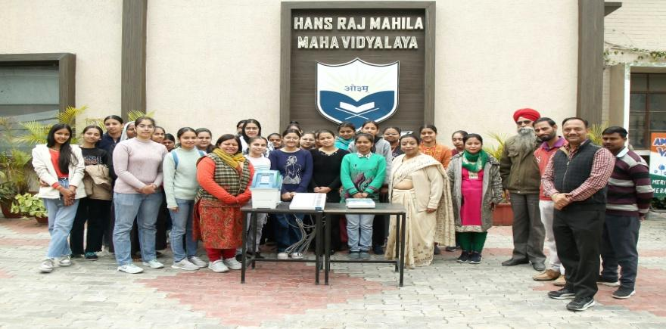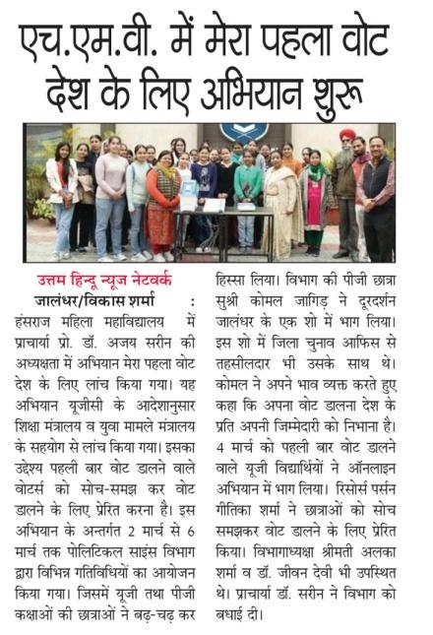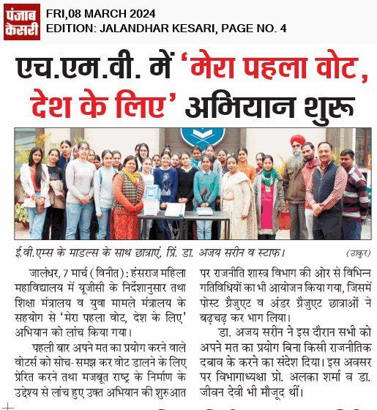
First-time voters were educated on how to use Electronic Voting Machines (EVMs) during their first visit to the polling booths, guiding them through the process of casting their votes. Finally, on March 6th, 2024, a workshop was conducted on Mera Pahla Vote Desh ke Liye in partnership with the Young India Foundation. First-time voters actively participated, guided by resource person Miss Geetika Sharma, who enlightened them on the significance of casting their votes wisely. Through a comprehensive PowerPoint presentation, she discussed the process of obtaining voter cards and emphasized how their participation in the electoral process can contribute to nation-building. On this occasion, Head of Department Mrs. Alka Sharma and Dr. Jiwan Devi were also present. Principal Dr. Sareen congratulated the department and said that every member and student of HMV family will definitely cast vote by exercising their right of voting.

